AWESEM Test Bench Getting Command Line Quick Start Guide

Note: Please refer to the prior quick-start guide for details regarding program installation and updating firmware along with the hardware pinout. It is assumed that the AWESEM Test Bench code along with all dependencies are already placed on the client machine and that the microcontroller has been flashed with the latest firmware.

1. Plug in the Teensy 3.2 into the PC
2. Go to the start search menu on the bottom left of the windows desktop and type “Anaconda Prompt”
   1. This is the search field as seen on the desktop: 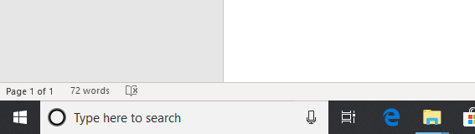
   2. After typing in “Anaconda Prompt” the application should appear in the search results as shown below 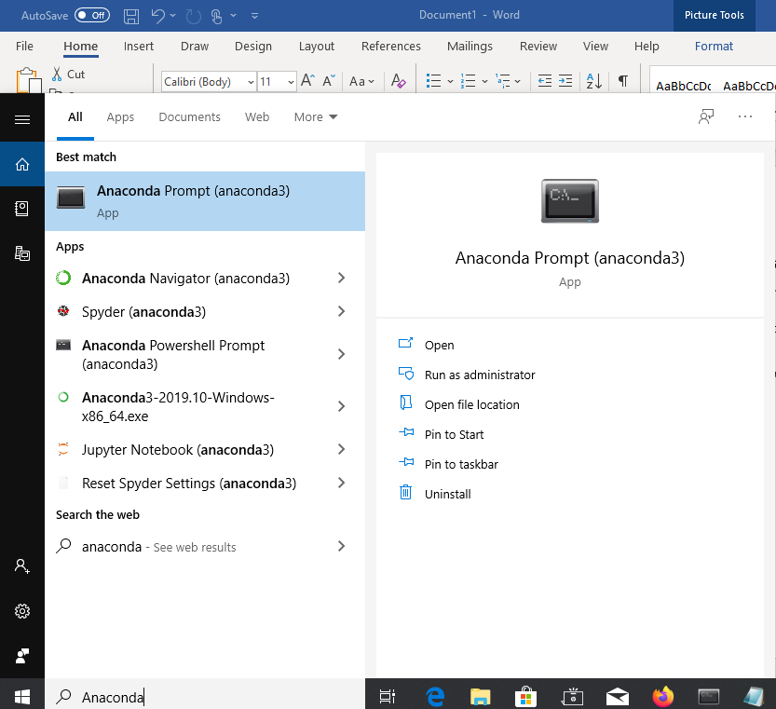
3. Double click this program in the results list, this will bring up a command prompt.
4. From the command prompt you can run an arbitrary python program by typing a command of the form “python [path/to/script.py]”. For this program we want to be running “AWESEM_Testbench_Main.py”. On the grey HP laptop type or copy the command ***python "C:\Users\rfpea\OneDrive\Desktop\Prakash_AWESEM\Version 2.0\Software\Main\QT Application v4/AWESEM_Testbench_Main.py"*** into the terminal and press Enter. Note that the quotations around the path are necessary due to spaces in the script path, if you receive an error make sure that enclosing quotes were used.
5. The AWESEM program should appear shortly.

Enabling Flyback Blanking

The software can be configured to only plot data on the rising or falling edge of either axis.

1. Once inside of the AWESEM Test Bench program, click on the “Reconstruction” tab along the right side as shown below:
   1. By default the program starts on the “Waveforms” tab, this is what it looks like before clicking “Reconstruction”: 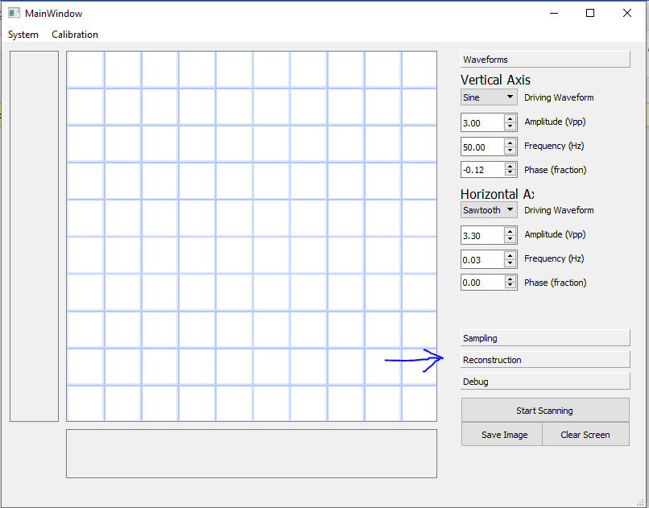
   2. After clicking the “Reconstruction” tab the following settings will be available: 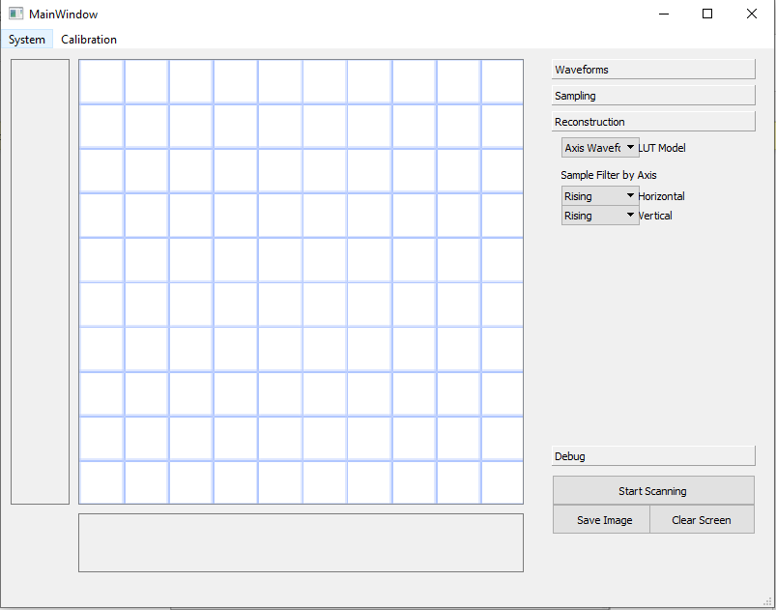
2. The reconstruction tab has three sub-fields
   1. LUT Model
      1. Use this to select how the program predicts motion of the stage given an arbitrary excitation. Typically the following options are available:
         1. Axis Waveform: Assume that the response is identical to the excitation wave with no distortion. Set response delay by changing the “Phase Fraction” setting under Waveforms.
         2. Linear: Assume that the response is a perfect sawtooth to any input
         3. Import Model: Allows you to open a plain-text description of the poles and zeros of the transfer function relating the driver voltage to mechanical excitation. This is typically built using the “Demos” Jupyter notebook found under ***Prakash_AWESEM\Version 2.0\Demos\PhaseDetection*** but can be made by hand.
         4. “Transfuc_...” or any other entries: These are SISO transfer function models and are typically found in the ***SysModels*** folder in the program directory. Load the model corresponding to the characterized stage.
            1. Note: once selected and when changing the driving waveform the program may appear to freeze for some time (10 seconds or so). This is also the only setting where the scale bars will appear.
   2. Sample Filter by Axis
      1. These settings can be independently set for both the horizontal and vertical axis. The following selections are possible:
         1. “All”: Intensity is plotted no matter the direction of displacement of the given axis
         2. “Rising”: Only plot points captured when the predicted displacement of the given axis is increasing in value (up or rightward on the screen) will be retained.
         3. “Falling”: Only plot points captured when the predicted displacement of the given axis is decreasing in value (down or leftward on the screen) will be retained.
      2. Note: a given point must pass both filters to be retained. Ex. If the vertical axis is set to “Rising” and the horizontal axis is set to “Rising” and a data-point is captured while the vertical axis is on a rising edge and the horizontal axis is on a falling edge will not be retained.
         1. A useful sample configuration may be to set both settings to “Rising” even when not using a sawtooth for both axes.